Net 1061 Switching, Routing, and Wireless Essentials

Name:

Lab: #

Follow the instructions down below for the lab itself. For this lab, all answers need to be in blue font. For the questions right below, answer in complete sentences. If this is a self-grading packet tracer. Ensure you paste the screen shot of your score page at the bottom of the document. You will upload both this document and the pkt file regardless if it is self-grading or not. Let the instructor know if you have any questions.

Lab Analysis Report

1. Using complete sentences summarize work you completed during the lab.
In this lab, I set up the network topology by adding the switches and cabling them. Then, I named the switches and configured all the ports as trunk ports. Finally, I assigned all the ports to their corresponding EtherChannel group.

2. Using complete sentences describe what you learned from the lab. Hint; look at the lab objectives listed at the top of the lab section.
In this lab, I learned more about EtherChannel and how to configure it fully. I learned how to configure it using different modes and different protocols.

Problems Encountered

1. Using complete sentences describe any problem(s) experienced during lab.
I didn’t experience any problems.

2. Using complete sentences describe how you solved your problem(s).

3. Using complete sentences explain if you needed any assistance with the lab; then list what you learned from that assistance.

Packet Tracer - Implement EtherChannel

Objectives
Part 1: Build the network
Part 2: Configure EtherChannel

Background
You have been assigned the task of designing an EtherChannel implementation for a company that wants to improve the performance of their switch trunk links. You will try several different ways of implementing the EtherChannel links in order to evaluate which is the best for the company. You will build the topology, configure trunk ports, and implement LACP and PAgP EtherChannels.

Instructions

Build the network.
Use the table below to build the switch topology.

Obtain the devices that are required.
      - Click the Network Devices icon in the bottom tool bar.
      - Click the Switches entry in the submenu.
      - Locate the 2960 switch icon. Click and drag the icon for the 2960 switch into the topology area.
      - Repeat the step above so that there are three 2960 switches in the topology area.
      - Arrange the devices into a layout that you can work with by clicking and dragging.

Name the devices.
The devices have default names that you will need to change. You will name the devices SWA, SWB, and SWC. You are changing the display names of the devices. This is the text label that appears below each device. It is not the host name. Your display names must match the names that are given in this step exactly. If a display name does not match, you will not be scored for your device configuration.
      - Click the device display name that is below the device icon. A text field should appear with a flashing insertion point. If the configuration window for the device appears, close it and try again by clicking a little further away from the device icon.
      - Replace the current display name with the appropriate display name.
      - Repeat until all devices are named.

Connect the devices.
      - Click the orange lightning bolt Connections icon in the bottom toolbar.
      - Locate the Ethernet straight-through cable icon. It looks like a solid black diagonal line.
      - To connect the device, click the Ethernet straight-through cable icon and then click the first device that you want to connect. Select the correct port and then click the second device. Select the correct port and the devices will be connected.
      - Connect the devices as specified in the table below.
Port Channel | Devices | Port Connections | Type
1 | SWA to SWB | G0/1 to G0/1 | PAgP
1 | SWA to SWB | G0/2 to G0/2
2 | SWA to SWC | F0/21 to F0/21 | LACP
2 | SWA to SWC | F0/22 to F0/22
3 | SWB to SWC | F0/23 to F0/23 | LACP
3 | SWB to SWC | F0/24 to F0/24

Configure EtherChannel
Open configuration window
On each switch, configure the ports that will be used in the Port Channels as static trunk ports.

Configure a PAgP EtherChannel.
Follow the procedure that was used in previous activities to configure Port Channel 1 as a PAgP EtherChannel between SWA and SWB. Both sides should negotiate the EtherChannel.

Configure a LACP EtherChannel.
Configure Port Channel 2 as an LACP channel between SWA and SWC. Both sides should negotiate the EtherChannel.

Configure a Backup LACP EtherChannel
Configure Port Channel 3 channel as an LACP channel between SWB and SWC. In this case, SWC initiates negotiation with SWB. SWB does not initiate negotiation of the channel.
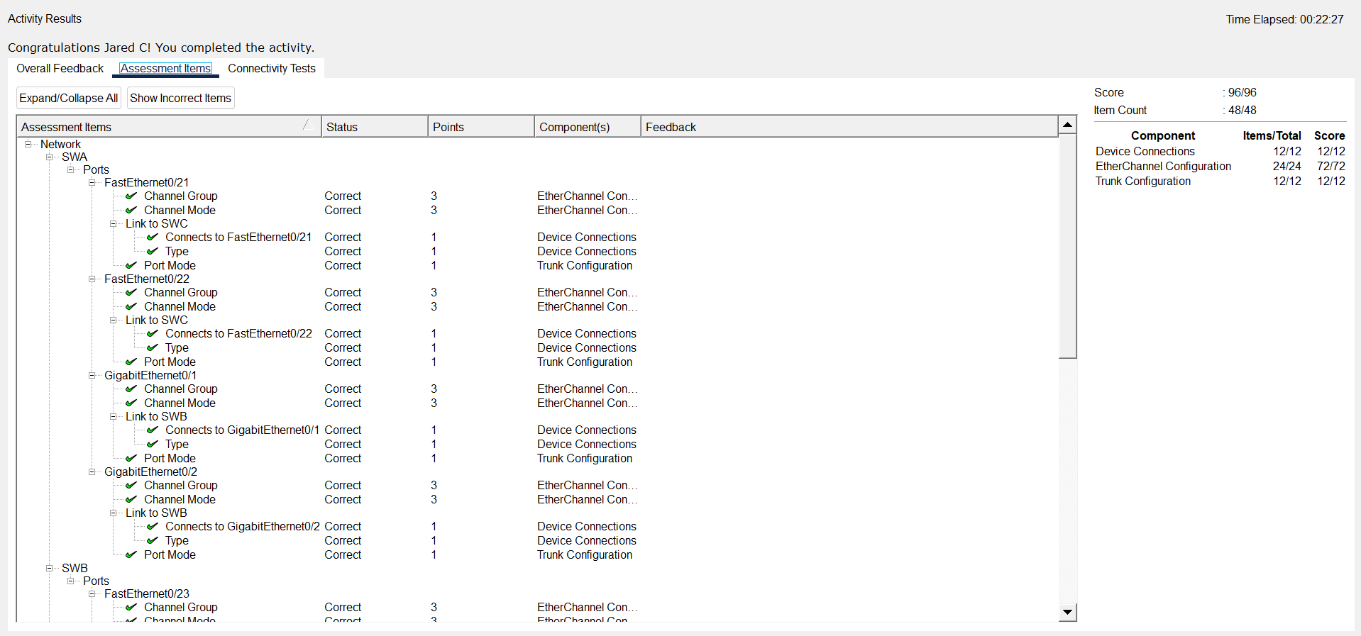
Close configuration window
End of document

